Program

American Eurhythmics Society

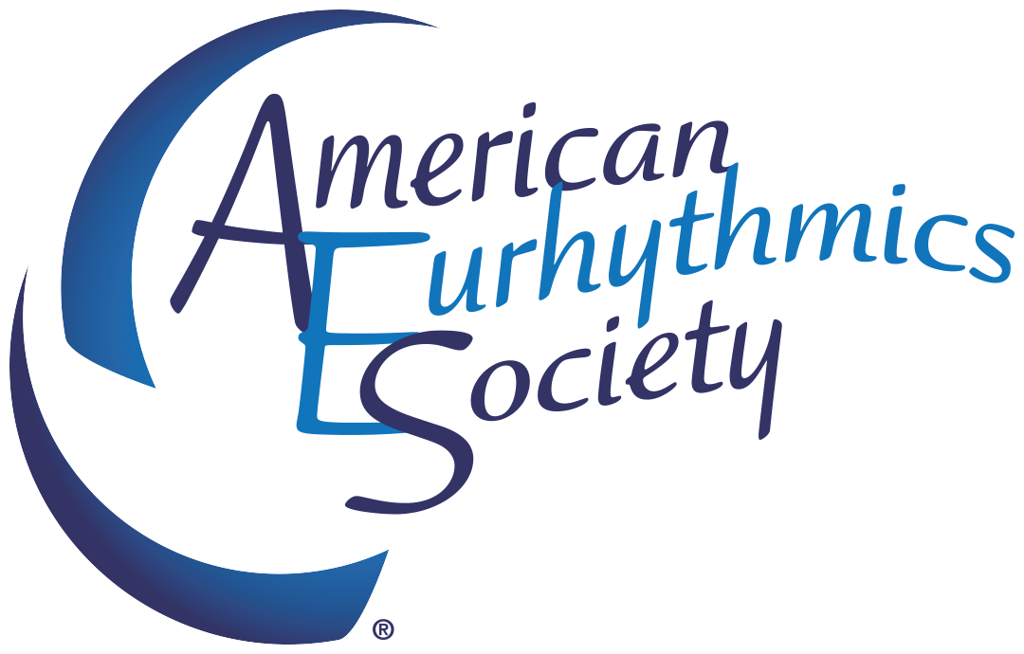

Virtual Spring Workshop
February 5, 2022
8 AM- 1030AM PST

AES Virtual Spring Workshop Schedule
February 5, 2022
8 AM- 1030 AM PST

8:00 Welcome– Kay Piña, President

803-810 Mini #1–“"Body Part and Duration Response (Family Time by Ziggy Marley)” Deborah Graham Gibson

8:10-8:40 Session #1
Crystal Henricks “Is there a game?” followed by live Q/A
Session Description: Come explore ways to adapt eurhythmic activities into motivating games the children will ask to play again and again.

8:40-8:45 Mini #2– “Stop and Go (Nat Adderly’s Work Song)” Skye McManus (from the work of Andrew Davidson)

8:45-9:20- Session #2 Oren Logan “Call to Creativity: Inspiring Movement in Children” followed by a live Q/A
Session Description: Creative movement can be intimidating. Learn strategies for using limitations to make creativity easy, fun, and accessible activities for all!

9:20-9:25 BREAK

9:25-9:30 Mini #3- "Feeling Pulse & Phrasing for Musical Shape (Nocturne by Clifford Poole)” Clinton Pratt

9:30-10:15 Session #3 Tiffany Unarce Barry “Filipino Folk Songs”
Session Description: Come sing songs and learn about Filipino history and culture through music from the Philippines!” (put your questions in the chat, there will be a follow up video from Tiffany)

10:15-10:20 Mini #4- “SHAKE IT OFF (by Taylor Swift) & FREEZE!” Kay Piña

10:20-10:25 Breakout Rooms

10:25 Kay Piña and Skye McManus– Closing and Plastique “I Don't Think About You Anymore But, I Don't Think About You Anyless” (Hungry Ghosts)

About Our AES Spring Workshop Presenters
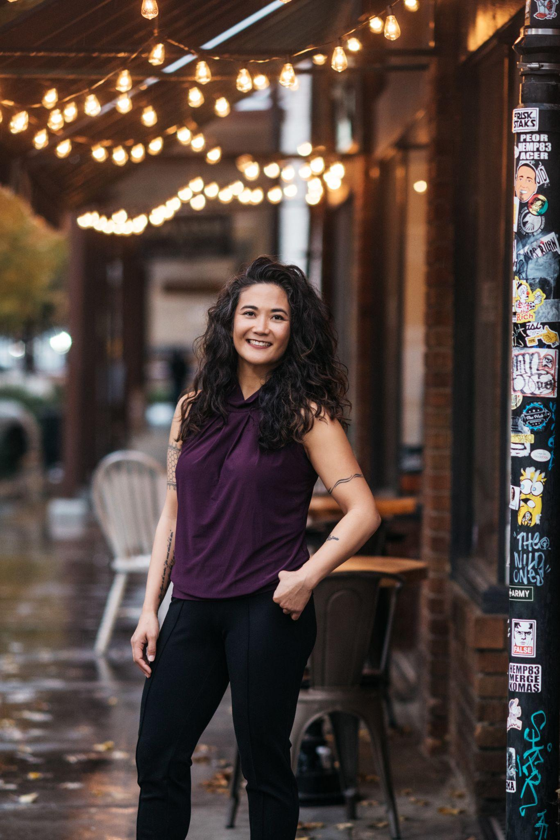 | Tiffany Unarce Barry has taught general music, band, choir, orchestra, and ukulele for almost 15 years in the California public school system. She is currently an adjunct professor in the School of Music & Dance at San Jose State University and a K-8 music teacher at Granite Bay Montessori in Roseville, CA.
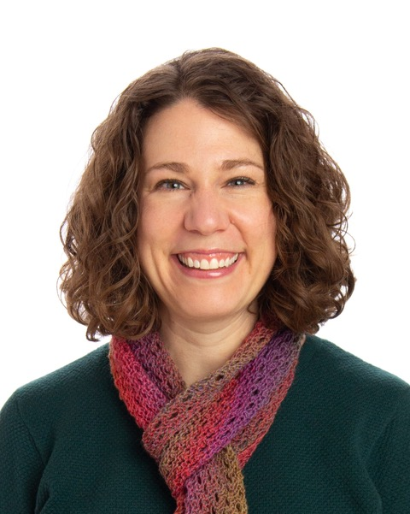 | Crystal Henricks currently teaches lower school music at the University of Chicago Laboratory Schools. Her experience includes Nursery School-12th grade general and choral music, both in Chicago and China. She holds a BS in Music Education from Asbury College, Kodály Certification and MMEd from Capital University, and is a Master Teaching Artist with the American Eurhythmics Society. She is an active clinician for workshops throughout the United States.
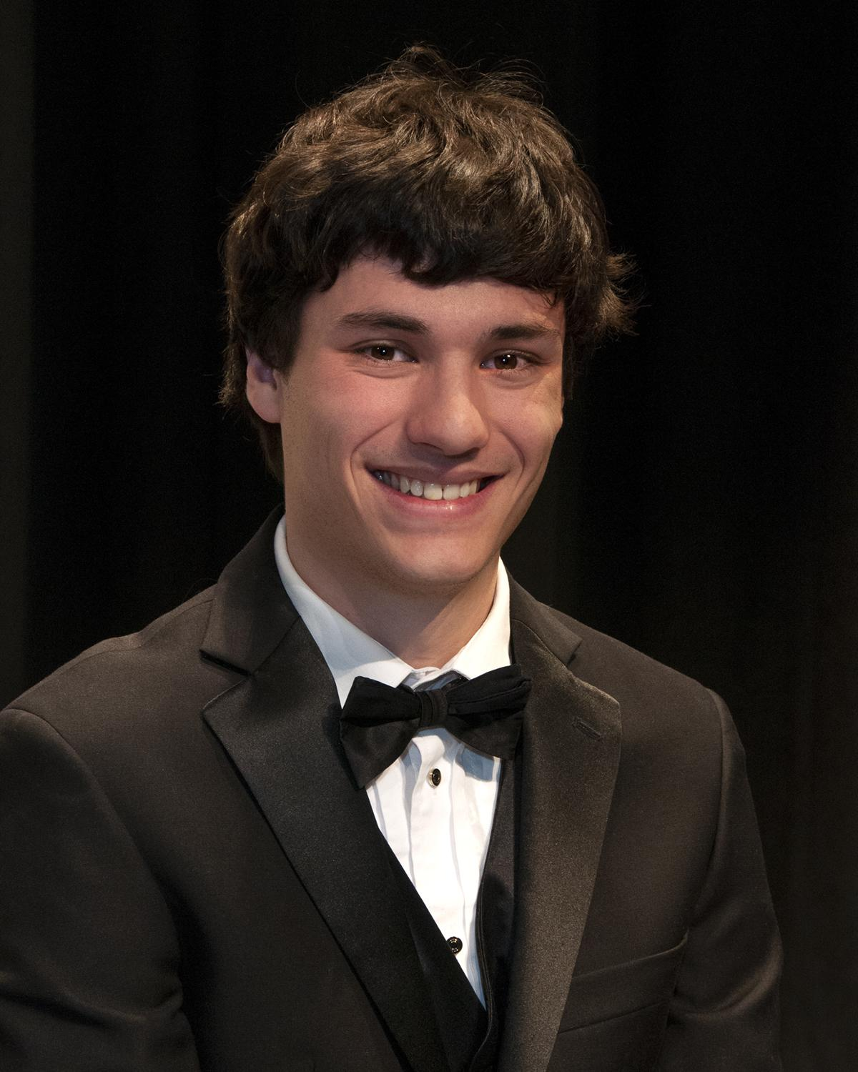 | Oren Logan is an Elementary Music Teacher at Olander School for Project-Based Learning in Fort Collins, CO. Since graduating in Fall 2017 from Colorado State University in Music Education, he has worked with students in grades K-8. He serves on the board of AES Colorado. Oren has presented on Eurhythmics at the Colorado Music Education Association (CMEA) conferences.
Mark Your Calendar!
AES National Conference 2022
Friday, October 7 - Saturday October 8, 2022
Tentatively scheduled in
Central Texas

Become A Member! Discount Code AESSPRING2022
For $10 off (valid ONLY 2/4/2022 - 2/16/2022)

Check Out Our Upcoming Events
Scholarships Available For Summer Workshops!!

Check out our newsletter

AES Collaborations
